Lab 8: Access control vulnerabilities - OAuth2.0
Objective:
- This lab object is designed to explore and identify vulnerabilities in OAuth implementations. Participants will use a simulated environment where an OAuth 2.0 setup is implemented with intentional security flaws. The objective is to detect, exploit, and suggest mitigations for these vulnerabilities.
In this lab, students need to:
- Answer the following questions:
  - What is OAuth, and how does it facilitate authorization in modern web applications?
  - Describe how consent phishing can be executed in an OAuth context. How can attackers leverage OAuth permissions to gain unauthorized access to user data? Discuss strategies that can be employed to detect and prevent consent phishing in OAuth implementations.
- Perform challenge:
  - Authentication bypass via OAuth implicit flow
- Explain and capture all steps (full windows screen capture).

Submit a report addressing all the questions mentioned above in either PDF or Markdown format. Additionally, include a video demonstrating the detailed process of your work to ensure the authenticity of your lab exercise.
The report file name must be Class_YourStudentID _YourName_Lab8

Authentication bypass via OAuth implicit flow
This screenshot shows Burp Suite capturing the OAuth login traffic in the lab “Authentication bypass via OAuth implicit flow.”
The request to /callback appears after the OAuth provider redirects the user back to the website.
By analyzing this request, we can see how the application handles OAuth tokens and parameters like state.
If these values are not properly validated, an attacker may bypass authentication and log in without valid credentials.
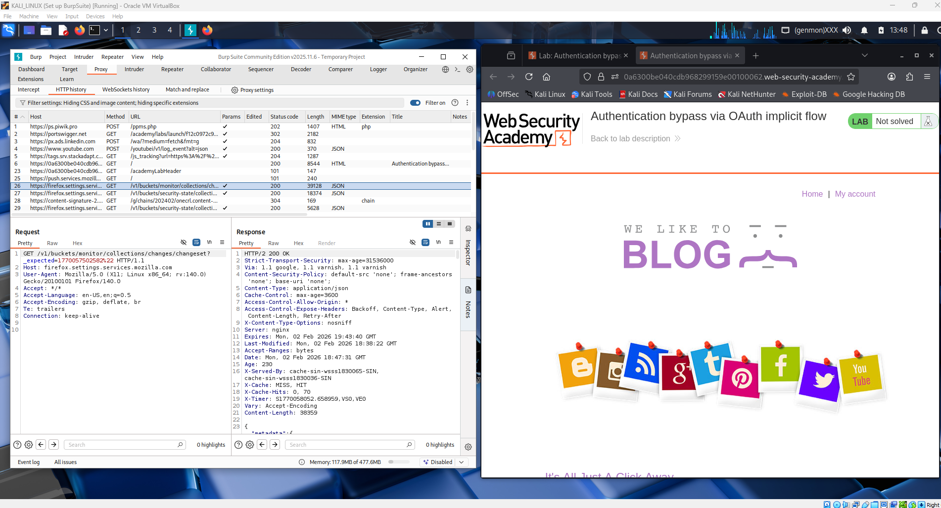
This screenshot shows Burp Suite intercepting the OAuth authorization request during the login process.
The request contains parameters such as client_id, redirect_uri, and response_type=token, which indicate the use of the OAuth implicit flow.
The server responds with a redirect to the OAuth provider for user authentication.
This step helps analyze how the application starts the OAuth flow and whether the parameters can be manipulated for an authentication bypass.
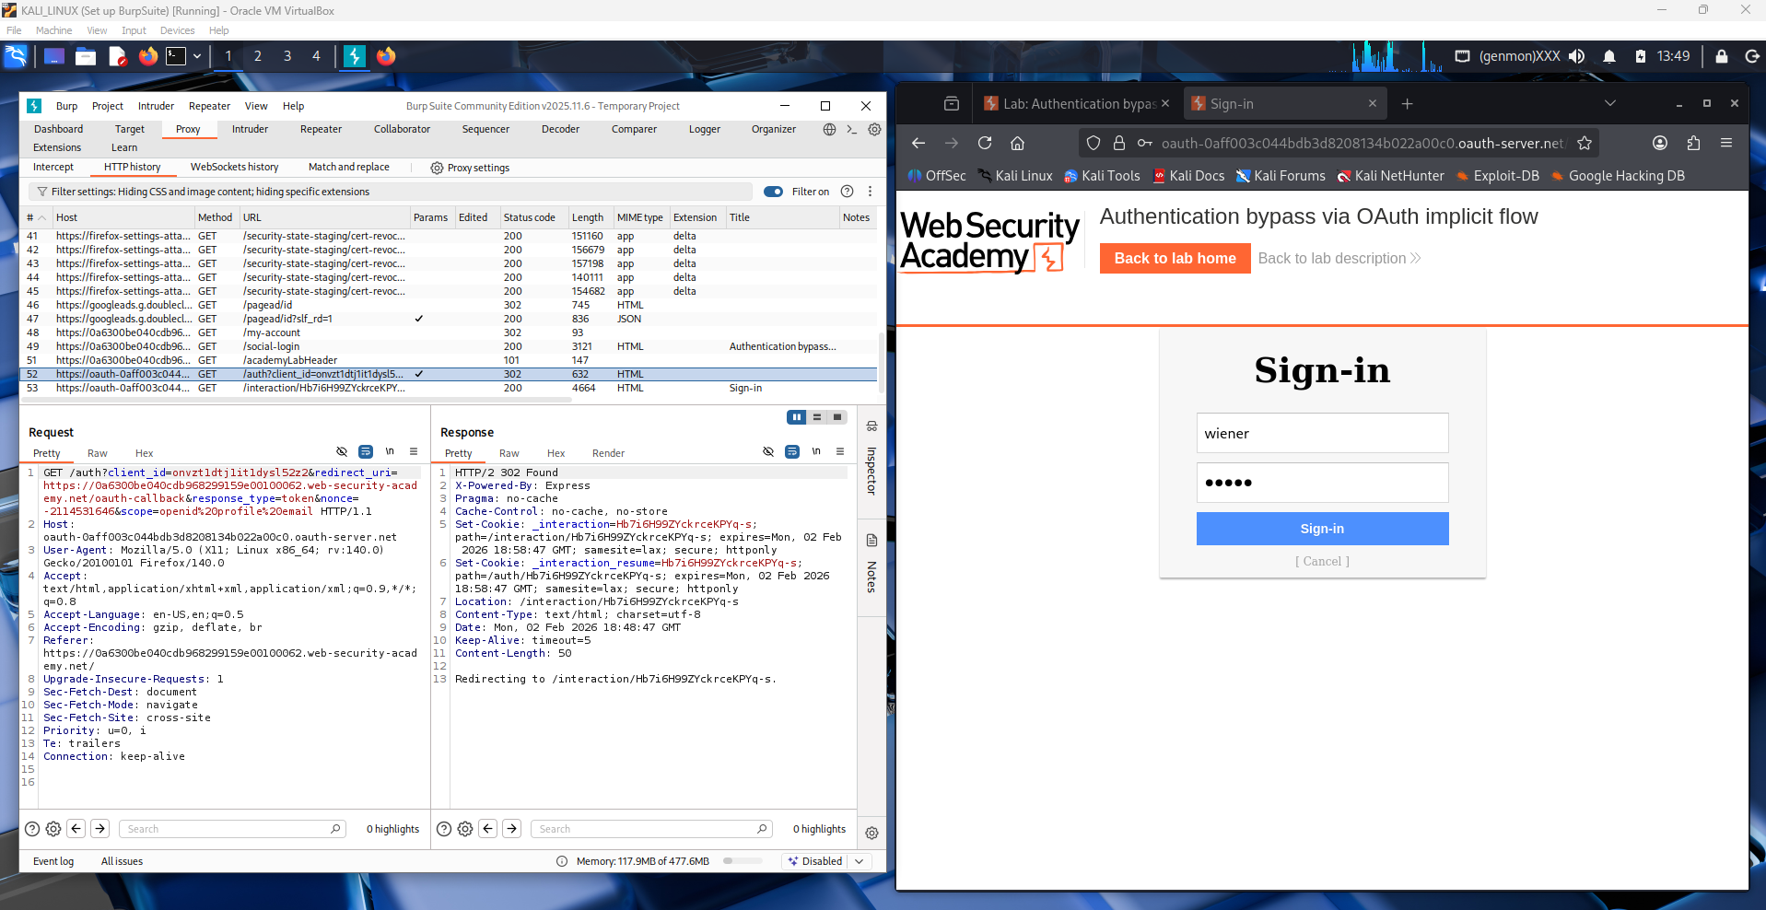
This screenshot shows the OAuth authorization (consent) page after the login request is sent.
The user is asked to allow the application WeLikeToBlog to access profile and email information.
Burp Suite captures the request and the redirect response from the OAuth server.
This step is important because granting consent allows the app to receive an access token that can be abused if validation is weak.
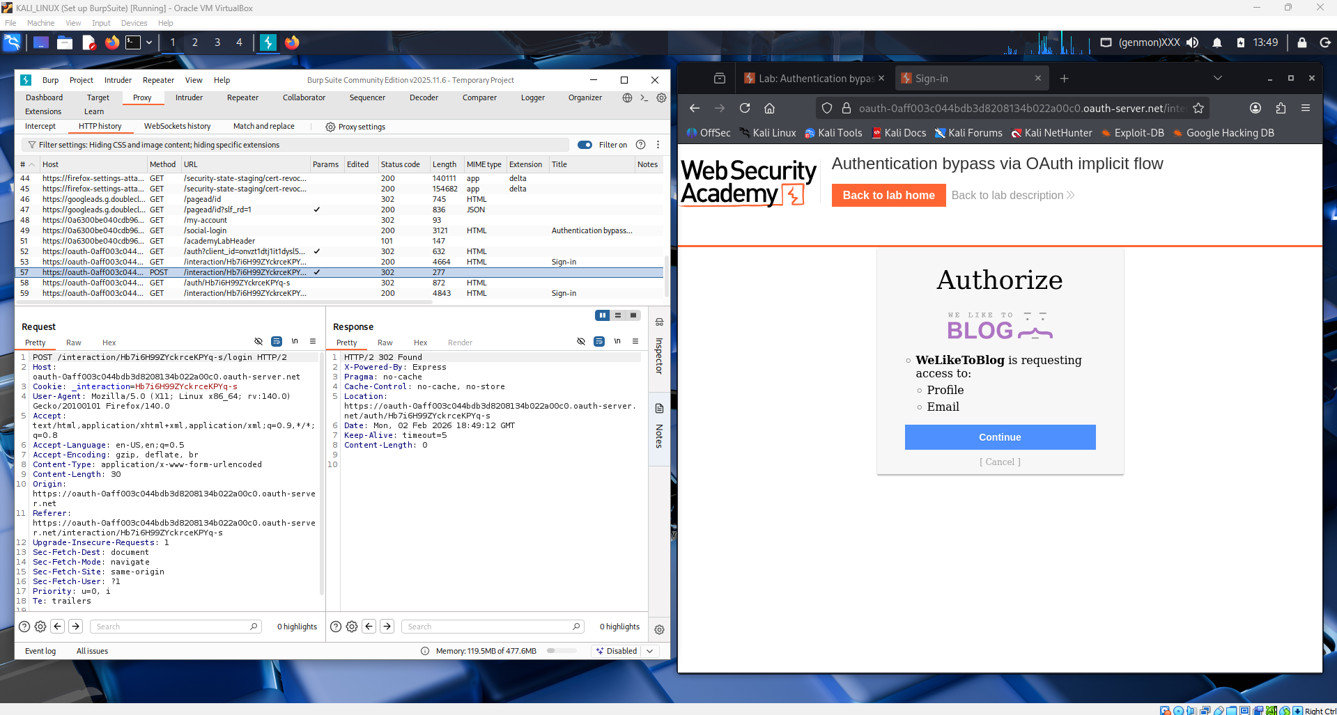

This screenshot shows the final OAuth response being captured in Burp Suite.
The request to /authenticate includes user data such as email, username, and an OAuth token.
The server accepts this token and creates a valid session without verifying proper authentication.
This demonstrates how weak token validation in the OAuth implicit flow can lead to authentication bypass.
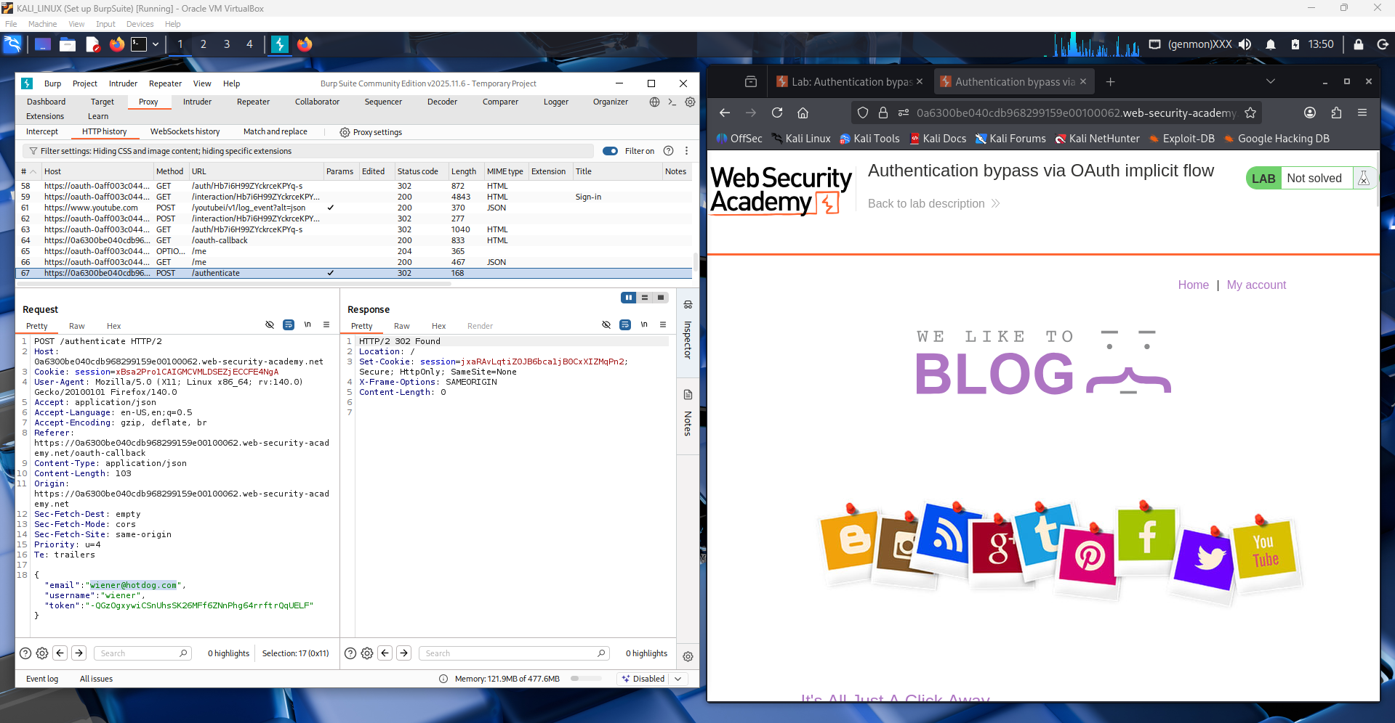
This screenshot shows the modified request being sent from Burp Repeater to the /authenticate endpoint.
The attacker changes the email and username to the victim’s account while keeping a valid OAuth token.
Because the server does not properly verify that the token belongs to that user, it accepts the request.
This allows the attacker to log in as another user, proving an OAuth authentication bypass.
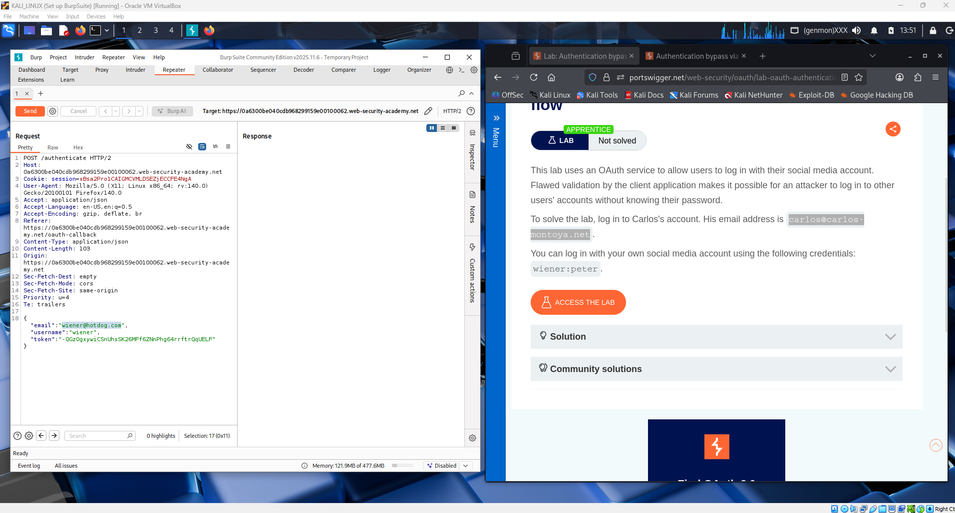
This screenshot shows the attacker editing the OAuth authentication request in Burp Repeater.
The email parameter is changed to the victim’s address while reusing a valid OAuth token.
The application fails to verify that the token matches the modified user details.
As a result, the attacker can access the victim’s account, demonstrating an authentication bypass vulnerability.
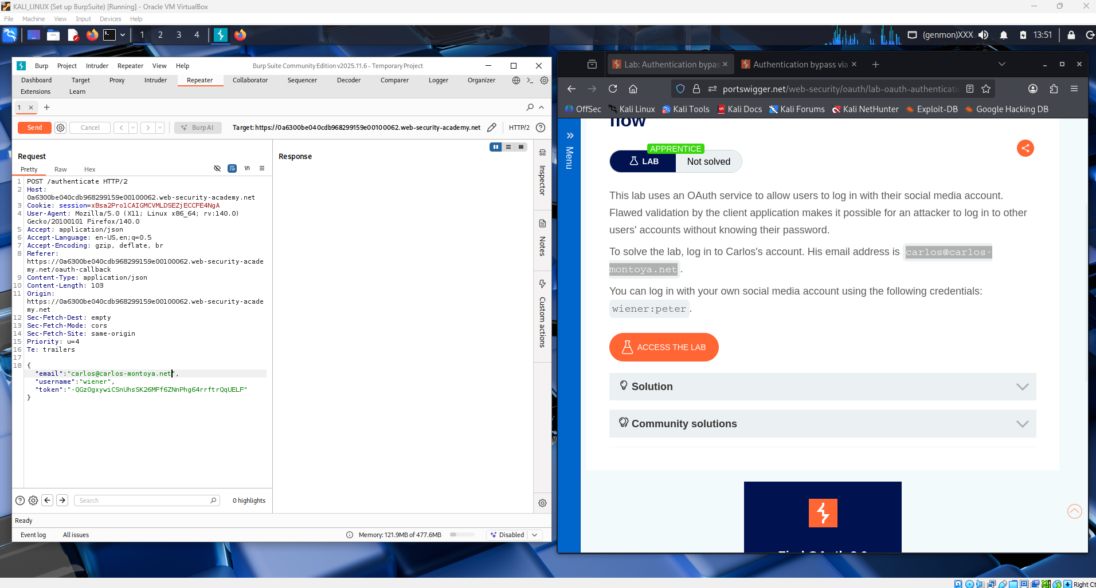

This screenshot shows the server’s response after the modified OAuth authentication request is sent.
The response includes “HTTP/1.1 302 Found” and sets a valid session cookie, meaning the login was successful.
Even though the attacker changed the email to the victim’s account, the server still created a session.
This confirms the OAuth validation flaw and proves that authentication bypass is possible.
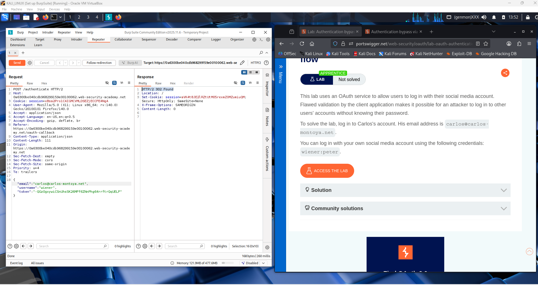

This screenshot shows the attacker using “Request in browser” from Burp Repeater.
This option sends the successful authenticated request to the browser with the new session.
Since the server already issued a valid session cookie, the browser is now logged in as the victim.
This confirms that the OAuth authentication bypass worked successfully.
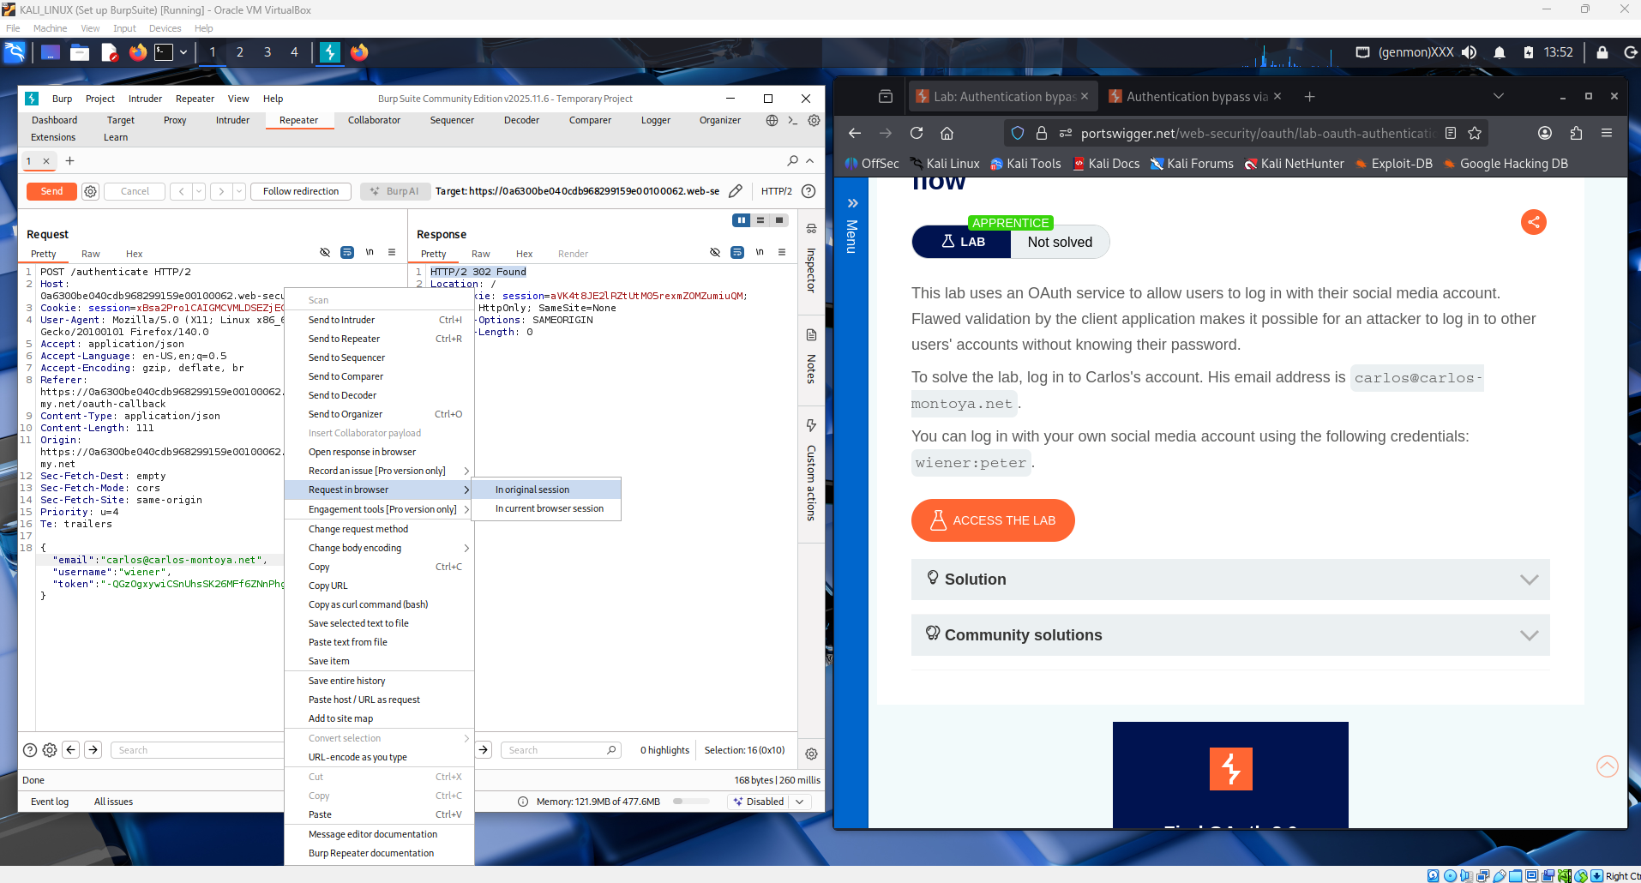

This screenshot shows the popup from Burp after selecting “Request in browser.”
Burp generates a special URL so the modified authenticated request can be opened directly in the browser.
By opening this link, the browser uses the valid session created by the server.
This step completes the attack and gives the attacker access to the victim’s account.
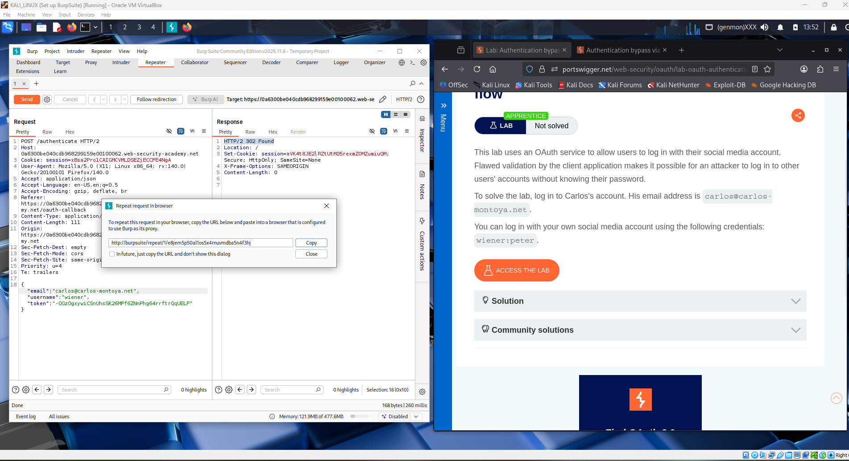
This screenshot shows the final result after sending the modified request to the browser.
The page displays “Congratulations, you solved the lab!”, confirming successful exploitation.
The attacker is now logged in as the victim without knowing the password.
This proves that improper OAuth token validation led to an authentication bypass vulnerability.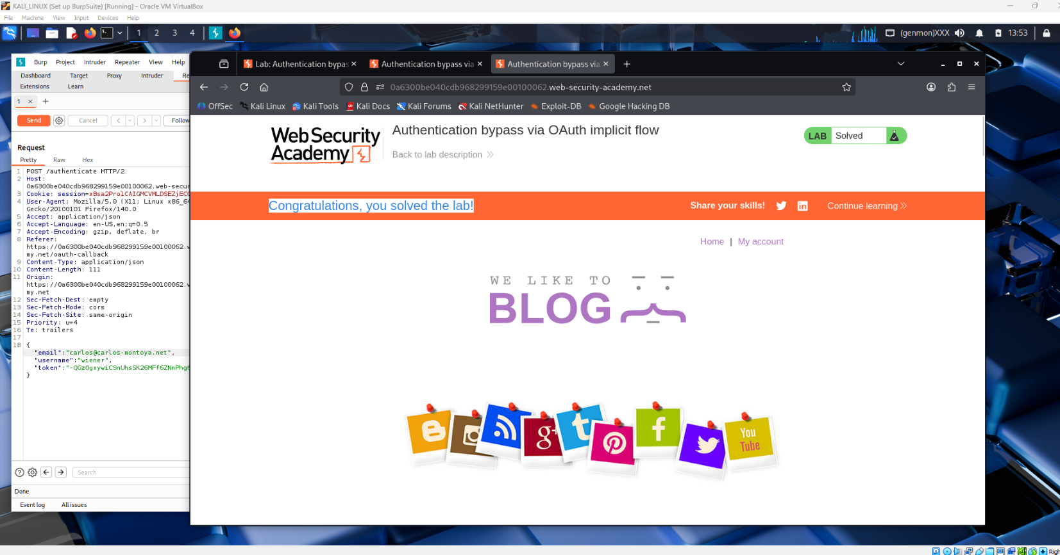
This screenshot shows the attacker accessing the My Account page after the exploit.
The page displays the victim’s username and email, proving the attacker is logged in as Carlos.
Burp Suite also shows the corresponding HTTP request and successful server response.
This confirms full account takeover through the OAuth authentication bypass vulnerability.
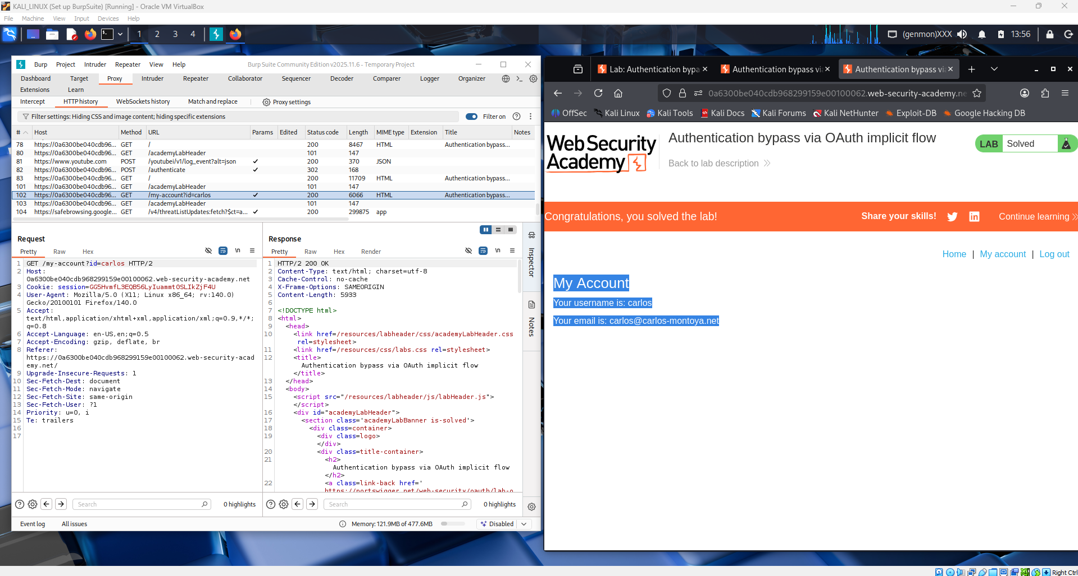

Conclusion:
This lab demonstrates how improper validation in the OAuth implicit flow can lead to a serious authentication bypass vulnerability. The application trusted user details sent from the client without verifying that the OAuth token actually belonged to that user. By modifying the email and username while reusing a valid token, an attacker was able to log in as another user without knowing their password.
This shows the importance of securely validating OAuth tokens, checking their integrity, and ensuring they are correctly linked to the authenticated user. Weak implementation of OAuth can result in full account takeover and serious security risks.

